

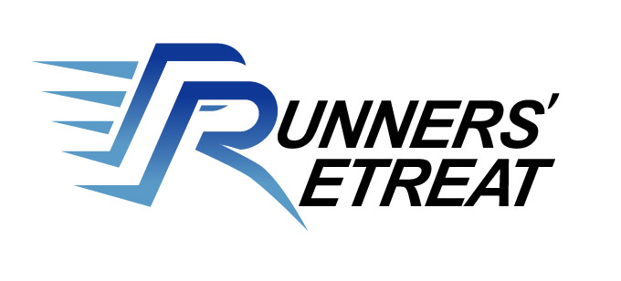
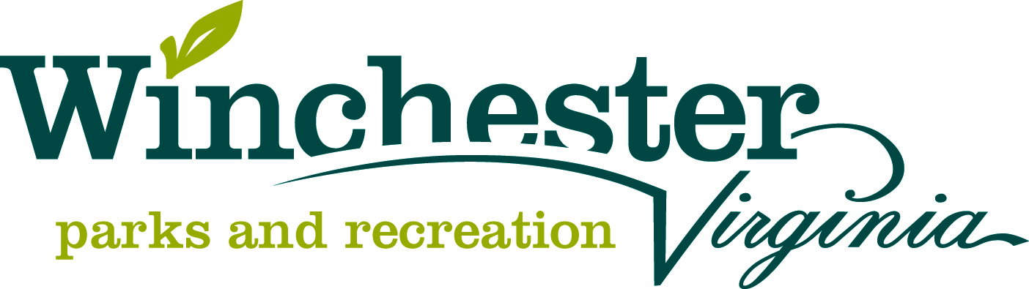


LOCATION: Jim Barnett Park in Winchester, Virginia. Winchester is approximately 12 miles from Berryville, 25 miles from Front Royal and Martinsburg, and 75 miles from Washington DC.

COURSE: The USATF-certified 5K course consists of a single loop around Jim Barnett Park and through the grounds of Shenandoah University using roads and sidewalks. There is a 45 minute time limit.
TIMING &
RESULTS: SVR will be using the Ipico Chip Timing System. Lost chips are a $5 fee to the runner.

AWARDS: Awards will be given to the top three men and women overall, first place male and female Masters (40 and over), and first place male and female Grand Masters (50 and over). Awards will also be given to the top three in the following age groups: 14 & Under, 15-19, 20-24, 25-29, 30-34, 35-39, 40-44, 45-49, 50-54, 55-59, 60-64, 65-69, and 70 & over.

KIDS MILE &
FUN RUN: Kid’s races will be held immediately following the 5K race! The Kid’s Mile is open to children ages 6-12. Awards for the Kid’s Mile will be given to the top two males and females in the following age groups: 6-8, 9-10, 11-12. A 100 yard dash will be open to children ages 2 to 5. The top male and female in this race will win an award.

ENTRY FEE: 5K entry fees: $18.00 for SVR members/$20.00 for non-members if received by June 24, 2013. $25.00 for all if received thereafter. Kids Run fees: $10.00 if received by June 24, 2013. $15.00 for all if received thereafter. T-shirts will be available on a first-come basis.

RACE DAY: Registration and packet pick-up will be from 6:45 to 7:45 AM. Show up early to make sure you get a t-shirt!

QUESTIONS: Contact race director Rosie Schiavone at (540) 667-0252 or rosieschiavone@comcast.net. You can also visit our website for ONLINE REGISTRATION at www.svrunners.org

PROHIBITIED
ITEMS: Bicycles, skateboards, strollers, roller skates, inline skates, animals, and radio headsets.

Random prizes! Refreshments! Participants can stay and swim at the
Jim Barnett Park for a discounted rate!

Name: _______________________________________________ Sex: M / F D.O.B.: __________________
Address: ________________________________________________________ Phone: ___________________
City: ________________________ State: _________Zip: ______________ Race (Circle one): 5K Kids Mile Fun Run
Email: ________________________________________________________
Shirt Size (circle one): Adult: S M L XL Kids: M L SVR Member? Yes No
Waiver: In consideration of accepting this entry, I do here by release the sponsors of Liberty 5K Race SVR and WPRD, jointly and separately, from any and all liability for illness, injury, and damages I may suffer as a result of my participation in this event. I certify I am medically fit to participate in this event. I understand the sponsors may use my name in the publicity and promotion of this event. I also understand that bicycles, skateboards, strollers, roller skates, inline skates, animals, and radio headsets are strictly prohibited.

Signature (Parent’s signature if under 18): _________________________________________________ Date: ___________________
Please make checks payable to:
“Shenandoah Valley Runners” and mail to:
Rosie Schiavone, 1040 Breckinridge Lane, Winchester, VA 22601

